Discrete Clinical Chemistry Analyzer
NS-Plus

On-Line Specifications (Rev.2.1)

Otsuka Electronics Co., Ltd.
November 29, 2007

Outline

1) NS-Plus is able to output the data to a host PC on real time basis or by a batch mode. NS-Plus is also able to send a inquiry to a host PC for receiving a work sheet from the PC.

2) Real time communication
The measurement data are sent to a host PC immediately after measurement of sample, calibrator and control.

3) Bach mode
The data that are selected in advance can be sent to a host PC.

- Use of real time or batch mode can be set up in the host PC property of the external output contained in the system configuration
- M rack cannot be the subject of sending an inquiry to a host PC for work sheet.

Type of data

 | Type | When? | Direction | Remarks
1 | Transfer of measure  -ment data(real time) | Measurement completed | NS-Plus ⇒ Host | Settable in the parameter setup
2 | Transfer of measure  -ment data(batch mode) | Result display and set for on-line communication | NS-Plus ⇒ Host
3 | Inquiry for WS | Sampling completed | NS-Plus ⇒ Host
4 | WS Receiving | After an inquiry was send | Host ⇒ NS-Plus

- The delay time of each bit can be settable by msec order. A the ex-factory, it is set to zero (0)
- Inquiry of WS and receipt of WS is not applicable to calibrator and control, only to sample.
- If dilution factor is registered on the display, no inquiry can be sent to a host PC. (The dilution factor registered on the display will take precedence.)

Definition of message

Text section
D: Measurement data
R: Inquiry for Work sheet
W: Work sheet

Sample section
U: Sample
C: Control
S: Calibrator

Sequence number
1 – 9999 are the numbers that are automatically issued by NS-Plus for identifying sample, calibrator and control. At ex-factory, they are set to:

Sample: 1
STAT: 8001
Control: 9001
Please note that the sequence numbers are re-set to the first number when the date is changed and go into the stand-by mode.

Rack ID, Rack position
Rack ID and position of the sample that were measured

Measurement method
One day, two days or three days method

ID
The maximum 14 character that are barcode- labeled on the sample. If it is smaller than 14 characters, the last past will be kept as the space.

Absorbance
Absorbance measured between 1 – 6.6 minutes

Concentration
Concentration calculated by a standard curve using the absorbance obtained between 1 – 6.6 minutes

Judgment
Judgment against cut-off value. A space is added in incase of calibrator and control.

Measurement date and time
Data and time of measurement performed

Remark
Indication of error that happened during measurement. Remark zero (0) means that measurement was done successfully, and any other number means results is unreliable.

Dilution factor
Factor for sample dilution

Measurement protocol number
Hemoglobin (A) 1
Hemoglobin (N) 2
Hemoglobin (GC) 3
Transferin (A) 4
Transferin (N) 5
Transferin (GC) 6

- (A), (N) and (GC) are equivalent to sample collection device A, N and GC.
Structure of text

STX and ETX are framed to the text data, and all text is described by the ASCII code. 4 digits Check-sum is added to the end of the text data. The check-sum is 4 bytes ASCII expressed by 16 hexadecimal of the total sum between STX and ETX.

・Measurement result data text
STX
STX
STX
ETX
ETX
ETX
Checksum
Checksum
(4 bytes)
Checksum
(4 bytes)
Measurement result data （fixed length：69 bytes）
(4 bytes)

・Inquiry to worksheet

Measurement result data （fixed length：15 bytes）

・Worksheet text data

Measurement result data（flexible length）

Data format

(1) Measurement data

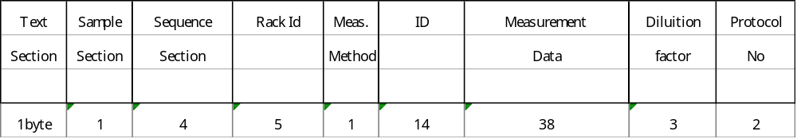

Item Byte(s) Example Description

Text section 1 D Type of text
Sample section 1 U Sample, Calibrator or Control
Sequence No. 4 7001 Sequential No. assigned to sample, calibrator and
control
Rack ID 3 001 Rack ID
2 1 Rack position（to be filled from the right）
Meas. method 1 1 1: 1day 2: 2day 3: 3day
ID 14 12345678 Patient ID（to be filled from the left）
Meas. data 5 0.012 Absorbance difference（to be filled from the right）
6 100 Concentration（to be filled from the right）
7 (-/-/-) Judgment (result)
10 2004/10/12 Measurement data
8 10:08:25 Measurement time
2 00 Remark code（Hexadecimal）
Dilution factor 3 1 Dilution factor（to be filled from the right）
Meas. Protocol 2 1 Measurement item（to be filled from the right）
Hemoglobin (A) 1
Hemoglobin (N） 2
Hemoglobin (GC) 3
Transferin (A) 4
Transferin (N） 5
Transferin (GC) 6

Total: 69 bytes（fixed length）

1) Concentration is obtained from the value calculated multiplied by “conversion factor of specimen container” and output to the PC. Conversion factor of specimen container is settable in the sample property of the system configuration.
2）If concentration has over-scaled, it is indicated by ***
3）If sample ID cannot be read, it is substituted by ?????
4）In case of use of NW7 for the sample ID, Start and Stop code will not be included in the sample ID.

Inquiry for work sheet

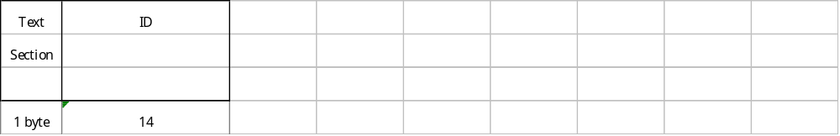

Item Byte(s) Example Description

Text section 1 R Type text
ID 14 12345678 Sample ID（to be filled from the left）

001-05 Or, rack ID position（to be filled from the left）
Rack ID is 3 bytes and position is 2 bytes. It is separated by – (minus).

Total: 15 bytes（fixed length）

1）If an inquiry is made by sample ID, ID filed will be set by sample ID. If it is by a rack position, it is set by a rack ID position. How to inquire can be set in the host computer property of the system configuration.
2）ID is set by sample ID in case of sample ID inquiry, and by a rack position ID in case of rack position ID inquiry. If sample ID cannot be identified, ID is set by ????

Work sheet

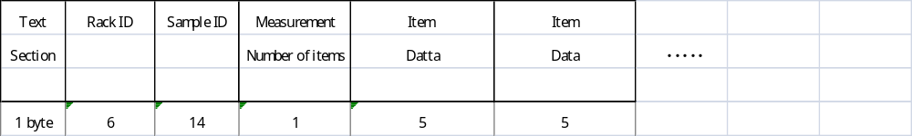

Item Byte(s) Example Description

Text section 1 W Type of text
Rack ID 6 001-05 Rack ID position (to be filled from the left)
ID 14 12345678 Sample ID（to be filled from the left）
Meas. No. 1 2 Number of measurements
Item 2 1 Protocol No.（to be filled from the left）
3 1 Dilution factor（to be filled from the right）

Total: Variable length

1）Work sheet length is variable according to the number of measurements.
2）Dilution factor should be 1or 10. If selected otherwise, 1 will be used.
3）In case of inquiry by sample ID, a space should be set to the position of rack ID.

How to transfer

Transfer protocol

1. NS-Plus sends ENQ（05H）to a host PC and wait for ACK(06H）from the host. If ACK(06H) is not received in 3 seconds, or if NAK is received, ENQ will be sent again. Retry will be attempted 6 times.

- Data text will be sent from NS-Plus to a host PC. A host PC will check a check sum in order to make sure that the data was transferred successfully.

3. ACK is returned to NS-Plus if received successfully, and otherwise NAK (15H) is returned. NS-Plus immediately return EOT (04H) to a host if it receives ACK. If NS-Plus receives NAK or no response from a host within 3 seconds, the data text will be transferred to a host PC again. Retry will be attempted 6 times. If no ACK returned from a host after 6 times re-tries, the process is terminated by sending EOT.

Transfer of measurement data

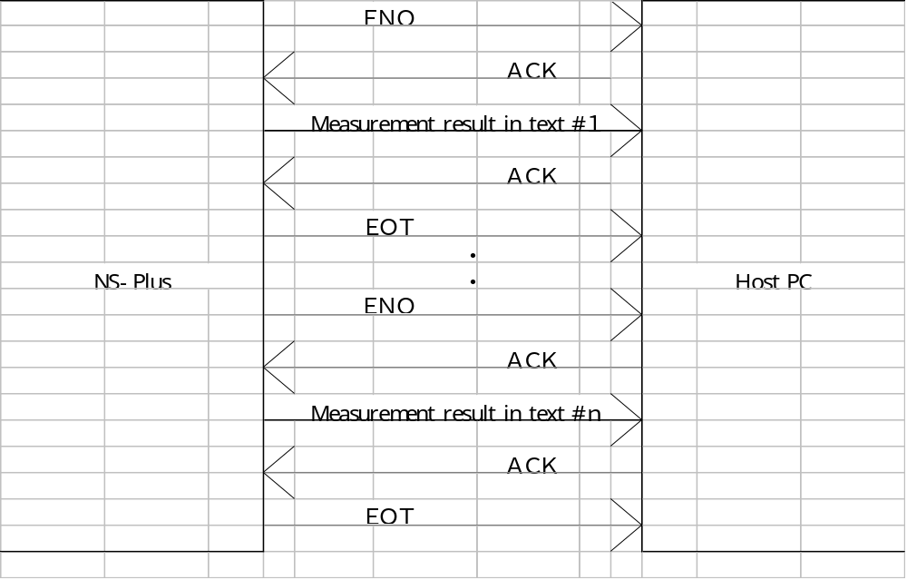

Inquiry for Worksheet and receiving Worksheet
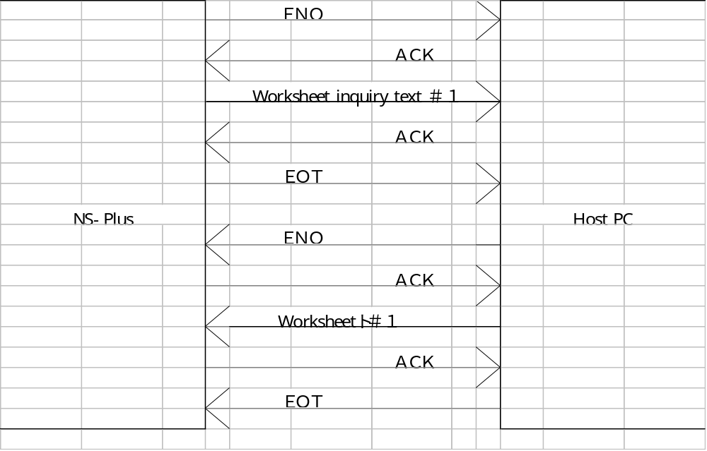

Hardware specifications

Connection
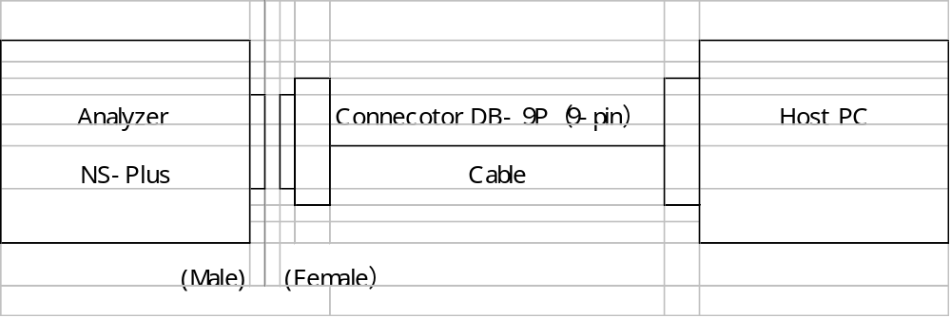

Transmission mode

１．Signal type: RS-232C
２．Synchronization: Start-stop synchronization、All duplicate
３．Speed: 9600 bps（Switching possible for 19200、4800、2400 bps）
４．Bit configuration: Start bit：１bit
Data bit：8bit (7 bit can be used.）
Parity bit：None（Can be switched to Even or Odd number）
Stop bit：1 bit（Can be switched to 2 bit）

Signal level

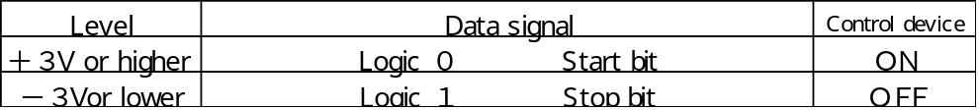

Space “０”
Mark “１”

↑１２３４５６７P↑↑
｜ ↑||
｜ ｜ -- ――Stop bit
｜ ｜
Start bit Parity bit

Interface for incoming signals（for 25pins）

- Terminal number vs. signals
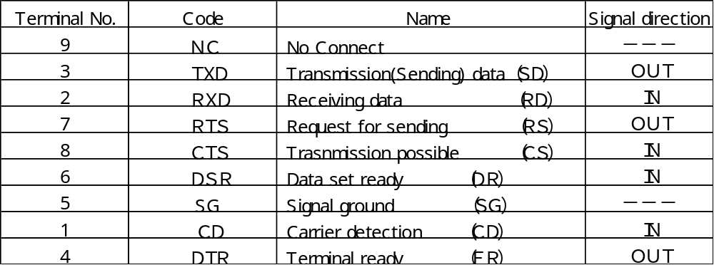

- Signal direction
OUT ――― NS-Plus Host
IN ――― NS-Plus Host

- Connection diagram（In case of connection as shown below）
- ＦＧ is not connected.
- ① and ⑥ of NS-Plus are connected.（⑤ is not connected.）

NS-Plus Host PC
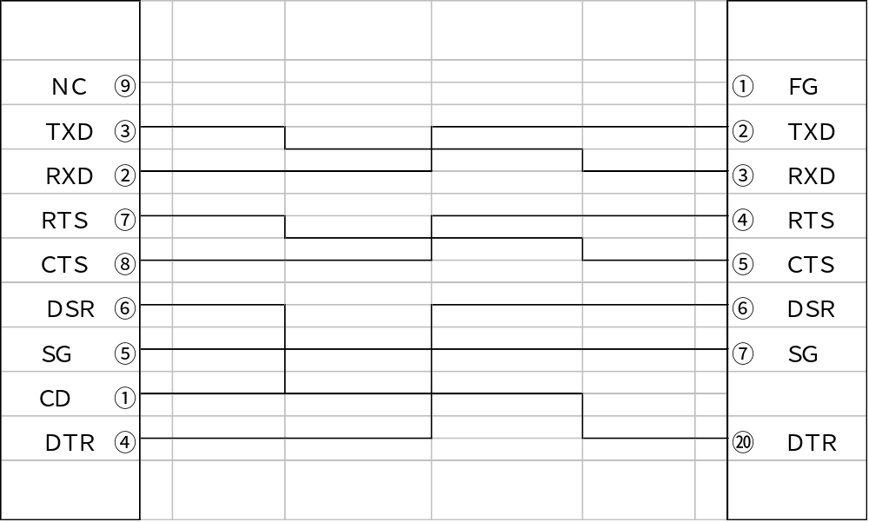

(3) Connection diagram（In case of connection as shown below）
- ＦＧ is not connected.
- ① and ⑥ of NS-Plus are connected.（⑤ is not connected.）
- ⑥ and ⑳ of host PC is shorted.（⑦ is not connected.）

NS-Plus Host PC
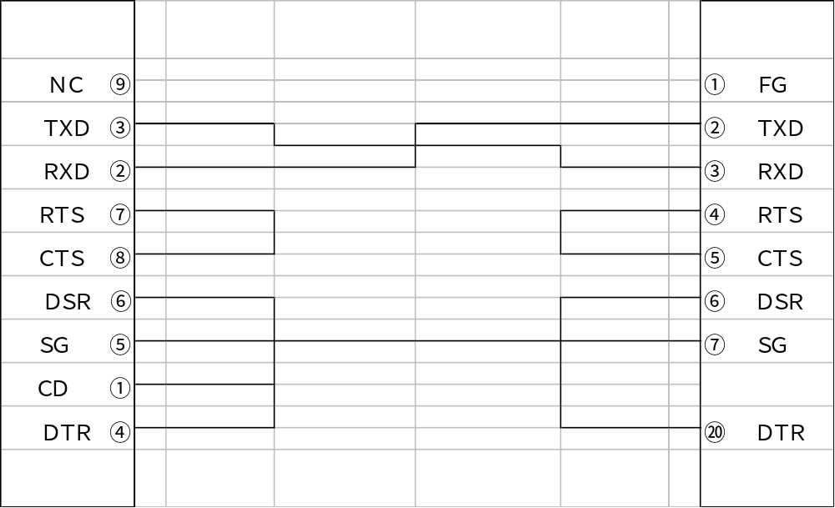

Interface for incoming signals（for 9pins）

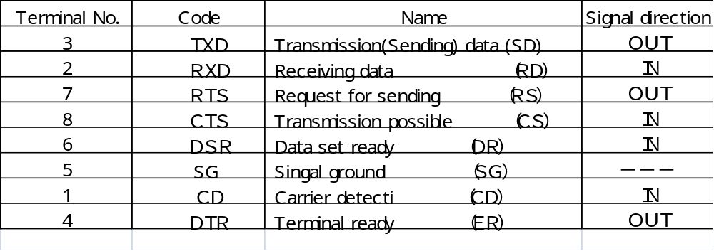

- Signal Direction
OUT ――― NS-Plus Host
IN ――― NS-Plus Host

- Connection diagram (9 pins)
Device Host
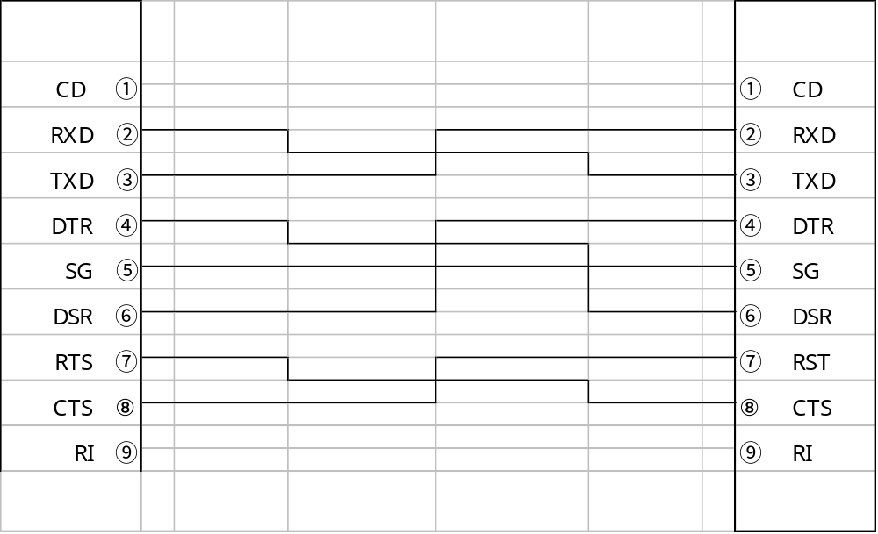

6．Remark code （ASCII, 2 bytes）

Measurement result may be followed by remark code in case of incidence possibly affecting the result such as sample shortage, reagent shortage. If no error detected, it followed by “00”.

Below shows the remark code. If multiple error should be detected concerning the same sample, ASCII code in 2-characters is used in combination of bits between 01 – 80. (Example: If R1 suction error and sample suction error should have happened with the same sample, it is followed by the code, 41. Concerning FF code, however, it will be indicated differently from such combination.

FF： Error of absorbance value after 1 minute
（This may happen when absorbance in 1 minute after R2 dispensing is over the shreshold level.）

Contents of errors Code, Code values

Suction error（R1,R2） 01 0 0 0 0 0 0 0 １
Suction error of diluents 02 0 0 0 0 0 0 1 0
Washing and DI water error 04 0 0 0 0 0 1 0 0
Error in the optics 08 0 0 0 0 1 0 0 0
Pro-zone detection error 10 0 0 0 1 0 0 0 0
Reagent lot error 20 0 0 1 0 0 0 0 0
Sample suction error 40 0 1 0 0 0 0 0 0
Error in judgment 80 1 0 0 0 0 0 0 0

＊）Reagent lot error may happen if the standard curve applicable to the reagent lot that was used for sample measurement doest not exist.

